**Part A:** Analysis of Variance

A drug company tested three formulations of a pain relief medicine for migraine headache sufferers. For the experiment, 27 volunteers were selected, and nine were randomly assigned to one of three drug formulations. The subjects were instructed to take the drug during their next migraine headache episode and to report their pain on a scale of 1 to 10 (10 being most pain).

Drug A: 4 5 4 3 2 4 3 4 4

Drug B: 6 8 4 5 4 6 5 8 6

Drug C: 6 7 6 6 7 5 6 5 5

1. Make side-by-side boxplots of the variable pain grouped by the variable drug.

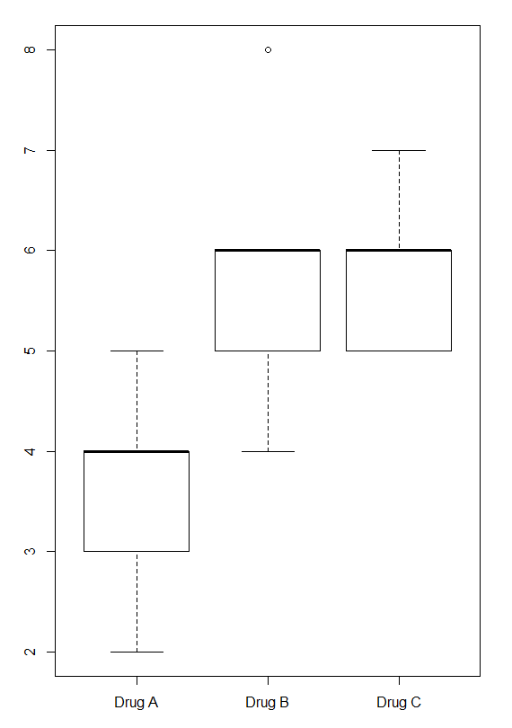

1. Interpret the boxplots in Part (1).

**Drug A boxplot:**

minimum value = 2

1st quartile = 3

2nd quartile (median) = 3rd quartile = 4

Maximum value = 5

There are no outliers

**Drug B boxplot:**

minimum value = 4

1st quartile = 5

2nd quartile (median) = 3rd quartile = 6

Maximum value = 6

Outlier = 8

**Drug C boxplot:**

minimum value = 1st quartile = 5

2nd quartile (median) = 3rd quartile = 6

Maximum value = 7

There are no outliers

1. Perform analysis of variance to test if there is a significant difference in means between the drug groups.

Firstly, we need to ensure that all assumptions for performing ANOVA test are met. The assumptions for this test include:

1. Data in Drug A, Drug B and Drug C should be normally distributed.
2. Homogeneity of variances should be assumed.

We perform ***normality test*** to check first assumption for our data. For this purpose I perform Shapiro-Wilk test on each data set.

**NORMALITY TEST**

**Drug A:**

$$H_{0}:Normality of Drug A can be assumed$$

$$H_{1}:Normality of Drug A can not be assumed$$

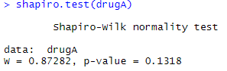

sig. = 0.1318 (p > 0.05)

Test is not significant

Accept $H_{0}$

Conclusion: normality of Drug A data can be assumed

**Drug B:**

$$H_{0}:Normality of Drug B can be assumed$$

$$H_{1}:Normality of Drug B can not be assumed$$

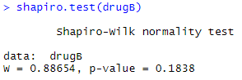

sig. = 0.1838 (p > 0.05)

Test is not significant

Accept $H_{0}$

Conclusion: normality of Drug B data can be assumed

**Drug C:**

$$H_{0}:Normality of Drug C can be assumed$$

$$H_{1}:Normality of Drug C can not be assumed$$

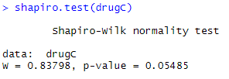

sig. = 0.05485 (p > 0.05)

Test is not significant

Accept $H_{0}$

Conclusion: normality of Drug C data can be assumed

Thereby, we got that all of our data is normally distributed. Now, we check for ***homogeneity of variances***. Since all data is normal, for this purpose I perform Levene’s test.

**TEST FOR HOMOGENEITY OF VARIANCES**

$$H_{0}: homogeneity of variances can be assumed$$

$$H_{1}: homogeneity of variances cannot be assumed$$

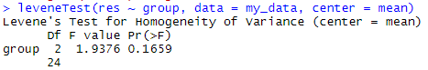

sig. = 0.1659 (p > 0.05)

Test is not significant

Accept $H_{0}$

Conclusion: homogeneity of variances can be assumed

The assumptions for performing ANOVA test are met. Now, we move to the test itself. As we have one independent predictor, we will use ***One-way ANOVA*** test.

**ONE-WAY ANOVA TEST**

$$H_{0}: all means are the same$$

$$H_{1}: at least two means are different$$

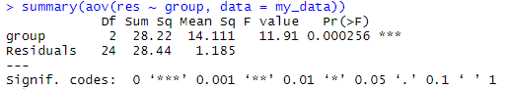

sig. = 0.000256 (p < 0.05)

Test is significant

Reject $H_{0}$

Conclusion: at least two means are different

In this One-way ANOVA test, a significant p-value indicates that some of the group means are different, but we don’t know which pairs of groups are different.

**Part B:** Multiple Comparisons.

The ANOVA F-test answers the question of whether there are significant differences in the $K$ population means. However, it does not provide us with any information about how they differ. Therefore when you reject $H_{0}$ in ANOVA, additional analyses are required to determine what is driving the difference in means.

1. Use planned contrast to compare the group means in Drug if knowing that the formulation of Drug B and C is similar.

Create contrasts based on the task description:

|  |  |  |  |
| --- | --- | --- | --- |
|  | A | (B | C) |
| C1: | 2 | -1 | -1 |
| C2: | 0 | 1 | -1 |

Transfer obtained contrasts to R Studio:

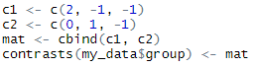

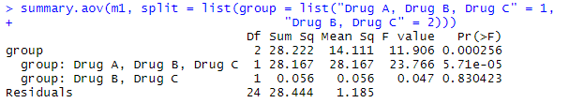

Now, we will find differences in means of drug types.

**Contrast 2:**

$$H_{0}: μ_{B}= μ_{C}$$

$$H_{1}: μ_{B}≠ μ_{C}$$

sig. = 0.830423 (p > 0.05)

Test is not significant

Accept $H_{0}$

Conclusion: means of Drug B and Drug C are equal

**Contrast 1:**

$$H_{0}: μ_{A}=μ_{B}= μ_{C}$$

$$H_{1}: μ_{A}≠μ_{B}= μ_{C}$$

sig. = 0.000057 (p < 0.05)

Test is significant

Reject $H_{0}$

Conclusion: means of Drug B and Drug C are equal, and not equal to the mean of Drug A

Answer: $μ_{A}≠μ_{B}= μ_{C}$

1. Use Bonferroni to run a pairwise comparison test between group means in Drug.

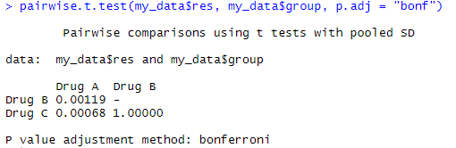

**Comparison 1:**

$$H_{0}: μ_{A}= μ_{B}$$

$$H_{1}: μ_{A}≠ μ_{B}$$

sig. = 0.00119 (p < 0.05)

Test is significant

Reject $H_{0}$

Conclusion: means of Drug A and Drug B are not equal

**Comparison 2:**

$$H_{0}: μ_{A}= μ_{C}$$

$$H_{1}: μ_{A}≠ μ_{C}$$

sig. = 0.00068 (p < 0.05)

Test is significant

Reject $H_{0}$

Conclusion: means of Drug A and Drug C are not equal

**Comparison 3:**

$$H_{0}: μ_{B}= μ_{C}$$

$$H_{1}: μ_{B}≠ μ_{C}$$

sig. = 1.000 (p > 0.05)

Test is not significant

Accept $H_{0}$

Conclusion: means of Drug B and Drug C are equal

Answer: $μ_{A}≠μ_{B}= μ_{C}$

1. Use TukeyHSD to run a pairwise comparison test between group means in Drug.

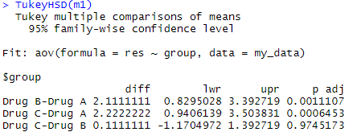

**Comparison 1:**

$$H_{0}: μ_{A}= μ_{B}$$

$$H_{1}: μ_{A}≠ μ_{B}$$

sig. = 0.0011107 (p < 0.05)

Test is significant

Reject $H_{0}$

Conclusion: means of Drug A and Drug B are not equal

**Comparison 2:**

$$H_{0}: μ_{A}= μ_{C}$$

$$H_{1}: μ_{A}≠ μ_{C}$$

sig. = 0.0006453 (p < 0.05)

Test is significant

Reject $H_{0}$

Conclusion: means of Drug A and Drug C are not equal

**Comparison 3:**

$$H_{0}: μ_{B}= μ_{C}$$

$$H_{1}: μ_{B}≠ μ_{C}$$

sig. = 0.9745173 (p > 0.05)

Test is not significant

Accept $H_{0}$

Conclusion: means of Drug B and Drug C are equal

Answer: $μ_{A}≠μ_{B}= μ_{C}$